Task: Task 20

Title: Custom Project Plan

Author: Sam Huffer, 101633177

# Instructions

From Doubtfire: “You must create a short plan document that describes what you plan to do in your custom project, and in particular identifies what artefacts you will create, including documents, work­ing code or other items such as videos, that demonstrate what you have achieved. This plan document will count towards your credit outcomes, even if you do not implement a custom project.”

# Custom Project Plan

For my custom project, I plan to create a customizable box world patrolled by soldier agents – and further populated with fugitive agents – using logic from Task 16: Goal-Oriented Action Planning and code from Task 18: Navigation with Graphs as a basis.

I will create a custom map for the box world and have a group of soldier agents patrolling corridors formed from wall tiles using group behaviours adapted for graph-based navigation. The fu­gitives will stay hidden until they see the soldiers, then they will attack them. The soldiers will respond by attacking them on sight until one or the other faction is wiped out. Dead fugitives will respawn randomly on the map away from the soldiers. The squad of soldiers will respawn if it is wiped out entirely.

Building on what I have already demonstrated in this unit in earlier tasks, fugitives will be subjected to a fear-mimicking mechanic where once they attack the soldiers, if their fear level be­comes too great, they will flee the soldiers. All agents will be subject to an explosives-avoidance me­chanic where if an explosive is fired or thrown, they will move out of its range. If the fugitives move outside all the soldiers’ awareness, the soldiers will scout the immediate area for the fugitives, resum­ing the attack if they find the fugitives, and resuming patrolling if they do not. If the soldiers become overwhelmed by the fugitives, one of them will return to their base and lead reinforcements back to the main group of soldiers.

# Technologies, Tools, and Resources to be Used

* SublimeText (for editing, executing and testing the code).
* Learning materials on Canvas (for instructions and sample code).
* Code and logic from Task 16: Goal-Oriented Action Planning and Task 18: Navigation with Graphs.

# Deliverables / Artefacts to be Produced

* A working simulation conforming to the above description.
* A PDF report document following the format of the spike reports, detailing the steps taken to implement the simulation and what I learned in implementing it, and including screenshots of the working simulation and key code it relies upon.

# State Diagrams

Figure : the state diagram for the Soldier agents.

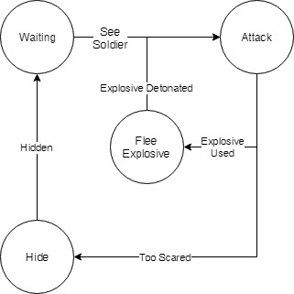

Figure : the state diagram for the Fugitive agents.